GREENHILL ACADEMY

ENGLISH LESSON NOTES
FOR P.1

TERM THREE – 2015

WEEK 2
THEME: TRANSPORT
SUB-THEME: Types and means of transport.
Lesson 1 and 2
VOCABULARY.
road lorry tractor
transport bicycle quickest
railway donkey slowest
water horse oxen
ship boat cart
air camel
motorcycle canoe
bus wheelbarrow

Activities
1. Reading through the vocabulary.

2. Constructing oral sentences using some of the above words.
Written exercise
3.Choose any ten words from the list above and use them in sentences.

Lesson 3 and 4
Structures
What is this/that?
This/that is----
What are these/those?
These/those are----- .
Where is ----?
It is a------- .
What is she/he doing?
She/he is------ .
Who is on ------?
They are ------- .
Where is/are the --------?
The ----- is/are ------- .
Reference
Monitor English book 2
MK English book 2

Lesson 5 and 6
Plural forms of irregular nouns.
Some nouns change their spellings when in plural form.
Noun Plural
tooth teeth
mouse mice
foot feet
ox oxen
man men
woman women
child children
louse lice
goose geese

Activity
Change nouns in brackets to plural form to complete sentences.
- She has white _________. ( tooth)
- He uses __________ to dig. ( ox )
- Jesca has _________ in her hair.( louce )
- The cat ate all the _________. (mouse)
- The____________ are playing football. ( man)
6.Those _____________ are very smart. ( woman)
7. The farmer sold ten __________ to Mr. Mwebe. ( goose )
8. The _________ are in the field. ( child )
9. Paul’s __________ are swollen. ( foot

Reference
Junior English book 2 pg
English Aid book 2

WEEK 3
Lesson 1 and 2
Comparison of adjectives.
Some adjectives double their last letter when there is a vowel before it.
In the comparative degree we double the last letter and add ‘er’.
In the superlative degree we add ‘est’ after doubling the last letter.
Examples
big bigger biggest
hot hotter hottest
fat fatter fattest
Activities
Complete correctly
wet ------- wettest
thin thinner ---------
-------- hotter hottest
flat flatter ---------
-------- -------- biggest
fat -------- fattest

Complete the sentences using the correct form of the words in the brackets.
1.She is the ------------- girl in the class. ( fat )
2.Mary’s tea is ---------- than mine. ( hot)
3.My bag is ------------- than his. ( big)
4.She is the ------------- girl in their family. ( thin )
Reference
Junior Eng book 2

Lesson 3 and 4
SUB-THEME: IMPORTANCE OF TRANSPORT
Conjunctions
Joining sentences using ‘and’
Activity
Making sentences about the pictures.
Example
1.Ali a car
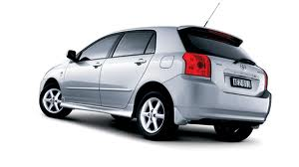
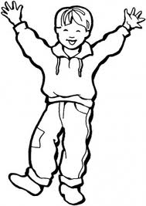

a lorry
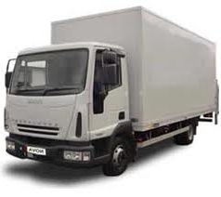

Ali has a car and a lorry.

2. Joy a pencil a book
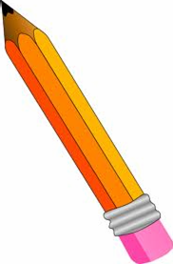

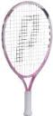
Joy has a pencil and a book.

3. Alex a ball a bat

Alex has a ball and a bat.
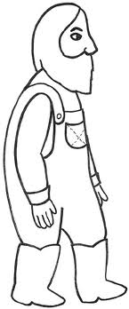
4. a farmer a hoe axe
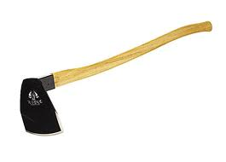
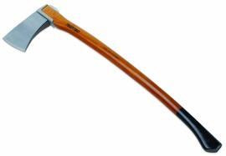

___________________________________________________

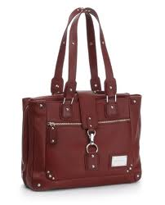

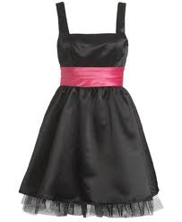
5. Mummy a dress a bag

__________________________________________________
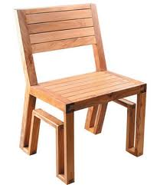
6. Tom a chair a table
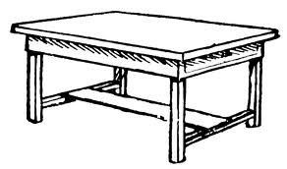

__________________________________________________

7. Mr. Brown a radio a television
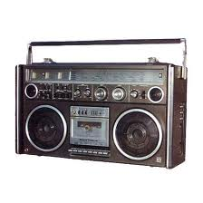

___________________________________________________
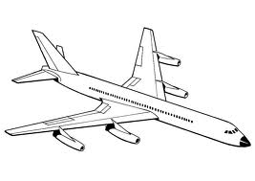
8. Mr. Kato an aeroplane a bus
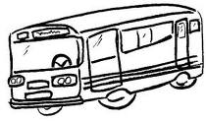

_____________________________________________________

Lesson 5 and 6
Joining sentences using ‘and’
Example
1. Jane is driving a car.
Mary is driving a car.
Jane and Mary are driving car
2. Tom is eating food.
Jim is eating food.
Tom and Jim are eating food.

Activity
1. Mummy is washing clothes.
Jane is washing clothes.
_______________________________________
2. Susan is doing homework.
Martha is doing homework.
______________________________________
3. Peter is reading a story book.
Joy is reading a story book.
________________________________________
4. Cedric is pushing a wheelbarrow.
Ryan is pushing a wheelbarrow.
________________________________________

Grace is fat.
Karen is fat.
_______________________________________

6. Daddy is reading a newspaper.
Mwebe is reading a newspaper.
______________________________________
7. Kato is running.
Wasswa is running.
______________________________________
8. The cow is eating grass.
The goat is eating grass.
_____________________________________

9. Barbra is swimming.
Claire is swimming.
_____________________________________
10. Sarah is singing.
Salome is singing.
____________________________________
Ref: Eng bk 2 page 31.
Oxford bk 1 pg 20-1

WEEK 4
Lesson 1 and 2
Joining sentences using ----and -----have
1. Apollo has a bicycle.
James has a bicycle.
Apollo and James have bicycles.

2. Sarah has a flower.
Loy has a flower.
___________________________________
3. Ben has a pen.
Paul has a pen.
____________________________________
4. David has a car.
Tom has a car.
_____________________________________
5. Musoke has a ball.
Mwebe has a ball.
____________________________________
6. Nalule has a bag.
Betty has a bag.
____________________________________
7. Musisi has a motorcycle.
Kato has a motorcycle.
____________________________________
8. Kate has a tractor.
Ronny has a tractor.
___________________________________
9. Peter has a donkey.
Tom has a donkey.
--------------------------------------------------------
10. John is riding a bicycle.
Alex is riding a bicycle.
-------------------------------------------------------

Reference
English Aid bk.2
Oxford bk. 1

Lesson 3 and 4

Joining sentences using ‘because’
Examples
1. John did not come to school.
He was sick.
John did not come to school because he was sick.
2. She missed the train.
She arrived at the station late.
She missed the train because she arrived at the station late.
Activity
1. Mummy did not go to work.
She was not feeling well.
____________________________________________
2. Joseph did not do his work.
He lost his pencil.
__________________________________________
3. The teacher punished him.
He shouted in class.
_________________________________________
4. Esther did not go to church.
Her clothes were dirty.
______________________________________
5. Father did not buy a new car.
He did not have enough money.
_______________________________________
6. Mark did not catch the bus.
He woke up late.
______________________________________
7. Tom cut his hair.
It was very long.
_____________________________________
8. The little girl cried a lot.
She was very hungry.
_____________________________________
9. James did not do homework.
He did not have a pencil.
------------------------------------------------------------
10. Ivan cried for a long time.
He hurt himself.
------------------------------------------------------------
Reference: Junior Eng Bk 1.
Read and write Bk 2.

Lesson 5 and 6

Join sentences using “but”
Examples:
1. Mummy gave you a sweet.
You did not thank her.
Mummy gave you a sweet but you did not thank her.
2. The boy fell down.
He did not cry.
The boy fell down but he did not cry.
Activity
Join the sentences using “but”.
1. Peter saw a snake.
He was not frightened.
_______________________________________________
2. My aunt has money.
She does not use it.
______________________________________________
3. Martin washed his shirt.
He did not iron it.
_____________________________________________

4. Moses has a pencil.
He did not do his work.
_____________________________________________
5. Alfred asked for some food.
He did not finish it.
_____________________________________________
6. Kevin has a pencil.
He did not do the work.
_____________________________________________
7. Mummy bought potatoes.
She forgot to buy beans.
_____________________________________________
8. She went to visit her sister.
She did not find her.
___________________________________________
9. Isaac has a story book.
He is not reading it.
__________________________________________
10. Cedric woke up early.
He reached school late.
___________________________________________
Ref:
Standard 2 Eng Aid pg………….

WEEK 5
Lesson 1 and 2
Similes as---------------as
(Comparing one thing to another)
Examples
as hot as fire.
as light as a feather.
as cold as ice.
as good as gold.
as white as snow.
as sweet as honey.
as thin as a rake.
as heavy as lead.
as busy as a bee / ant.
as black as charcoal.
as fast as lightning.
as happy as a king.
as proud as a peacock.
as big as an elephant.
as playful as a kitten.
as brave as a lion.
as fat as a pig.
as wise as an owl.
as poor as a church mouse.
as strong as a horse.
as mischievous as a monkey.
as timid as a rabbit.
as loud as thunder.
as easy as a, b, c

Activity

Fill in the missing words to complete the sentences.

1. Musa is as playful as a _____________
2. Phillip is as strong as a ----------------------
3. He is as wise as an ________________________________
4. Her dress is as white as ________________________________
5. Mummy’s hair is as black as ________________________
6. The old man is as poor as a ________________________
7. All the teachers are as busy as a _____________________
8. The box is as light as a _____________________________
9. My uncle is as __________________ as a lion.
10. Tony is as _____________ as a peacock.

Ref; Junior Eng. Bk .2 pg 87.
Junior Eng bk. 1

Lesson 3 and 4
Group Names
Group names e.g. furniture, fruit, birds, animals, building materials, vehicles etc
Group names – Names given to certain groups of things.
Examples
A cat, a goat, a pig all are animals.
A sparrow, a parrot, a robin, a weaver bird all are birds.
An apple, an orange, a jackfruit, a mango all are fruits.
A tent, a bungalow, a hut all are houses.

Activity
write a group name for each of the group of words below.
1. Red, Blue, Yellow, Orange and Green are all _______________________
2. Pears, apples, mangoes and jackfruits are all ____________________________
3. Rose, Lilly, tulip and daisy are all _________________________________
4. Lions, tigers, zebras, elephants and leopards are all______________________
5. Cows, goats, dogs, cats and sheep are all ______________________________
6. Wasps, mosquitoes, houseflies are all _________________________________
7. Coats, shirts, dresses, blouses and vests are all __________________________
8. lorries, buses, vans, motorcycles and tractors are all____________________________
9. Tables, chairs, benches, desks and beds are all _____________________
10. Uncles, aunts, grandmothers, cousins are all __________________________

Ref: English Aid bk. 2/3

Lesson 5 and 6

Collective Nouns
Names given to groups of objects e.g. Herd, bunch, fleet, etc
Examples
a herd of cattle
a herd of elephants
a chest of drawers
a bunch of keys A bunch of grapes
a fleet of cars
a swarm of bees
a flight of birds.
a gang of thieves
a crowd of people
a park of wolves
a team of players
a choir of singers
a flock of sheep
a shoal of fish
a bouquet of flowers
a bunch of flowers

Activities
1.Constructing oral and written sentences using any of the above collective nouns.
Examples
We saw a herd of elephants at the zoo.
A team of players was getting ready for the match.

2.Complete the sentences correctly.
1. A large _____________ of doves flew over the trees.
2. I have lost my _____________ of keys.
3. The clothes were kept in the _________________ of drawers.
4. A _______ of thieves broke into her shop.
5. There is a ___________ of cattle in the field.
6. A _____________ of people gathered in the park.
7. A ___________ of singers sang very well.
8. A __________ of cars moved slowly in the street.
9. A __________ of fish swam past the boat.
10. We saw a __________________ of sheep near our school gate.
Ref: English Junior bk. 1/2 59, 35
Progress in English pg----

WEEK 6

Lesson 1 and 2
Commas
Commas separate items in a list or sentences.
Commas help to pause in listing items in a sentence.

Examples
She bought bananas, meat, oranges, eggs and beans.
James has a long bag, a pencil, a ruler, a rubber and a book.
That farmer has cabbages, tomatoes, cassava, maize and yams in his garden.

Commas do not come after ‘and’
Activity
Punctuate correctly using commas.
1. John has a ruler a rubber a pen and a pencil in his bag.
________________________________________________________
2. Cats cows sheep and pigs are domestic animals.
________________________________________________________
3. Ann Ritah Jean Sarah and Joy are friends.
________________________________________________________
4. Moses Tom Fred and Sam are in Primary one.
________________________________________________________
5. Lorries cars bicycles and buses move on roads.
________________________________________________________
6. Mother father aunt and uncle came to visit us.
________________________________________________________
7. Animals trees people and insects are all living things.
________________________________________________________
8. She packed juice cakes sausages and apples for lunch.
________________________________________________________
9. Cassava sweet potatoes Irish potatoes and yams are food crops.
________________________________________________________
10. Kittens calves piglets and cubs are young ones of animals.
________________________________________________________

Ref:
-Junior Eng BK 2 pg 22.
-Essential Eng Workbook bk

THEME: THINGS WE MAKE.

SUB-THEME: THINGS WE MAKE AT HOME AND AT SCHOOL.
Lesson 3 and 4
VOCABULARY
mat hat a pair trousers
rope drum dress
basket shaker mortar
pot necklace pestle
ball bag wood
clay palm leaves banana fibres
sisal straws mingling stick
doll skirt knife
charcoal stove raffia soil
cow dung
reeds
animal skins
Activities
1.Reading through the vocabulary.

2.Constructing oral and written sentences using some of the vocabulary.

Lesson 5 and 6
Structures using some of the real objects.

This/that is a -----------
These/those are--------
Where is/are the--------?
It is/they are------------
What do we use to make a ---------?
We use --------to make ------------
What are you making?
I am making a---------
What are they doing?

WEEK 7

SUB THEME IMPORTANCE OF THINGS WE MAKE.

Lesson 1 and 2

Past tense of irregular verbs

Irregular verbs are verbs which don’t take‘d’ or ‘ed’ in the past tense but change the spelling.
Examples of irregular verbs

Verbs past tense
blow blew
eat ate
run ran
sit sat
go went
come came
do did
see saw
sell sold
tell told
grow grew
fly flew
drive drove
break broke
know knew
pay paid
say said
think thought
write wrote
catch caught
fight fought
get got
buy bought
speak spoke
draw drew
take took
make made
Activities
- Pick any words from the list and use them in sentences.

Lesson 3 and 4

B.Fill in the gaps with the past tense of the words given in brackets.

1. She _______________ to him on telephone. (speak)
2. He __________ his work very fast. (do)
3. My father ____________ to his house to see him. (drive)
4. The child _____________ his milk bottle. (break)
5. Paul _____________ a nice picture of an elephant. (draw)
6. My mother _______________ all the bills. (pay)
7. I ______________ the letter to Mark. (write)
8. The cat _______________ a rat in the store. (catch)
9. Nancy ______________ all the money to me. (give)
10. She _____________ down and hurt herself yesterday. (fall)
11. We ________________ the books in the drawer. (keep)
12. The teacher ________________ us well. (teach)

Ref: English Aid Bk 3 pg 29-30.
English Aid BK 2 pg
Junior Eng. Bk 2 pg 4

SUB- THEME: IMPORTANCE OF THINGS WE MAKE.

Lesson 5 and 6
Similar
Different words with same meaning.
weep cry
finish end
start begin
stop halt
start commence
creep crawl
tug pull
tear rip
stout fat
large big
speak talk
assist help
wide broad
rich wealthy
goodbye farewell
look gaze
reply answer
present gift
repair mend

Activity

In place of each underlined word, write a word which has a similar meaning.
- I start work at eight o’clock. ________________
- Snakes creep along the ground. __________________
- John gave Jane’s hair a playful tug. ________________
- A large crowd saw a fire game. ____________________
- They do not speak to each other now. __________________
6. Cars must halt at the cross roads. _____________________
7. Can you assist me, please? _________________________
8. We stopped to gaze in the zoo.______________________
9. Carol had a lovely present from her aunt. _______________
10. We reply when a teacher asks a question. ________________

Ref: Junior English bk 1 page 63 and 32.
Bk 2 pg 23 and 59.

WEEK 8
Lesson 1 and 2
Analogies
Examples
1. Cat is to kitten as calf is to cow.
2. Dog is to bark as lion is to roar.
3. Boy is to girl as father is to ________________
4. Bird is to nest as lion is to _________________
5. Frog is to jump as butterfly is to ___________

Activity
1. Cow is to beef as pig is to _________________
2. Ship is to sea as bus it to __________________
3. See is to eyes as smell is to _________________
4. Blouse is to girl as shirt is to ________________
5. Goose is to geese as foot is to _______________
6. King is to queen as bull is to _________________
7. Big is to small as long is to ___________________
8. Doctor is to hospital as teacher is to ___________
9. Nephew is to niece as uncle is to ______________
10. Happy is to sad as late is to ___________________

Ref: Junior Eng bk 2 pg 67.
Junior Eng bk 1
Lesson 3 and 4
Homophones - Words with same sound but different meaning.
year - ear
here - hear
Week - weak
plain - plane
tail - tale
Son - sun
right - write
bye - buy
road - rode
sail - sale
dear - deer
knows nose
there - their
hours ours
pair - pear
know - no
heal - heel
too - two
check - cheque

Choose the correct word given in brackets to complete the sentences.
1. We hear with our ears. (years, ears)
2. There is nobody ________________. (here , hear)
3. The _____________ rises in the east. (son, sun)
4. There are seven days in a _____________. (weak, week)
5. My _______________ hand is paining. (right, write)
6. Our teacher wants to ___________ our books. (check, cheque)
7. Where is my ______________ dress? (new, knew)
8. That is _______________ house. (there, their)
9. Two halves make a _____________. (whole, hole)
10. The monkey has a long ________________. (tail, tale)
Ref: English Aid 3 pg. 66.
Junior Eng. Bk. 2 Pg. 21, 51, 79.

Lesson 5 and 6

THEME: OUR ENVIRONMENT.

SUB – THEME: Components and importance of things in our environment.

Vocabulary
people rabbit food
land cow medicine
river lion shelter
lake snake
mountains zebra
bird sheep
dog turkey
elephant hills
monkey transport

Activities

- Reading through the vocabulary.

- Constructing oral and written sentences using some of the vocabulary.

WEEK 9
Lesson 1 and 2

Animal homes.
Examples
Lion - den
cow - kraal
dog - kennel
horse - stable
bird - nest
fish - water
monkey - trees
rabbit - hutch/burrow
sheep - byre/pen/fold

Activities

Match correctly.
lion nest
cow water
dog yard
horse den
bird trees
fish hutch
monkey kraal
rabbit stable
sheep kennel

Complete the sentences correctly.
- A bird lives in a ____________ .
- A cow lives in a ____________ .
- A ________ lives in a stable.
- A ________ lives in a kennel.
- A rabbit lives in a ________ .

Lesson 3 and 4
Young ones of animals.
Examples
Sheep - lamb crocodile - hutchling
cat - kitten rabbit - bunny
cow - calf lion - cub
dog - puppy snake - snakelet
horse - stable bird - nestling
frog - tadpole duck - duckling
fish - fry elephant - calf
man - baby goat - kid

Complete correctly.
Animal young one
horse ________
cow ________
goat ________
rabbit ________
bird ________
dog ________
cat ________
lion ________
duck ________
sheep ________
pig ________

Lesson 5 and 6
Animal weapons
Examples
bird - beak
dog - teeth
snail /tortoise - shell
man - hands
cow /goat - use horns and legs
chameleon - changes colour
cat - claws
snake - poisonous fangs
bee - sting
horse - legs
caterpillar - prickly hair
millipede - coils itself

Activity
Complete correctly.
Animal weapon
cat ________
caterpillar ________
snake ________
_____ horns
bird ________
dog ________
_____ hands
_____ fangs

WEEK 10
THEME: PEACE AND SECURITY.
SUB- THEME: Peace and security at home.
Vocabulary.
hold knife obedience
throw spear respect
play stick peace
cut stone maids
fight fire parents
help gun
share protection

Activities
Reading through the vocabulary.
Constructing oral and written sentences using some of the vocabulary.

Structures
Who has /have _______?
Who is/are __________?
What is /are ______ doing?
Revision
-Present continuous tense

Peace and security at school.
- Past tense of irregular verbs.
- Similars

Peace and security in our community.
_Inviting a resource person.
- Gender
- similes

GREENHILL ACADEMY

NEWS LESSON NOTES
FOR P.1

TERM THREE

GREENHILL ACADEMY

LITERACY LESSON NOTES
FOR P.1

TERM THREE

